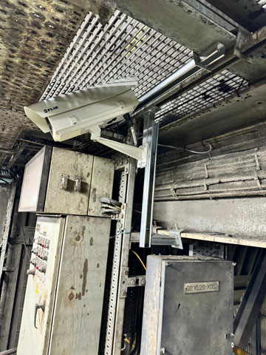

*The FLIR A500f and A70 thermal imaging cameras are used at the Moneypoint power plant.*

**Turning up the heat on grid reliability:**

How FLIR thermal vision is protecting a quarter of Ireland’s electricity grid from cascade failure blackouts

***Automated thermal monitoring brings early fire detection and continuous condition monitoring insights to major Irish power station***

In a power station, where a fire could trigger a grid shutdown affecting up to 25% of Ireland’s electricity supply, the need for early fire detection isn’t just a matter of efficiency; it’s an essential part of national stability.

This reality was made starkly visible during the [April 2025 blackouts in Spain and Portugal](https://edition.cnn.com/2025/04/28/europe/spain-portugal-power-outages-intl),[1] which left millions without power, disrupted hospitals and rail systems, and sent shockwaves through Europe’s energy sector.

While the root cause remains under investigation, the cascading effects of a single grid failure reignited urgent questions around energy infrastructure resilience and underscored the dangers of inadequate detection systems.

Overcoming problematic failure points

To meet that challenge, [ESB Energy](https://www.esbenergy.co.uk/)[2], in conjunction with [Butler Technologies](https://www.butlertech.ie/?srsltid=AfmBOor8RoGbK6Yfk8zesK8SK9t7p-rHuHUWs1UxKup9_TBwh9g3y0zo)[3], has deployed a cutting-edge end-to-end thermal monitoring system using FLIR technology.

It provides real-time alerts, enhances engineer responsiveness, and helps futureproof energy infrastructure as it transitions to green power.

On Ireland’s rugged west coast, Moneypoint Power Station, a legacy site refitted to operate as an oil-burning plant, is now setting a new benchmark for safety and resilience. With a fully integrated thermal monitoring system in place, the site is changing how critical assets are managed. It is delivering round-the-clock visibility, precise early fire detection, and actionable condition monitoring insights.

In an energy landscape where [experts now warn](https://www.carbonbrief.org/qa-what-we-do-and-do-not-know-about-the-blackout-in-spain-and-portugal/)[4] that grid fragility could lead to repeat scenarios of international disruption, this Irish installation offers a timely case study in how intelligent monitoring can stop local issues from becoming continental catastrophes.

This installation, led by ESB and Butler using FLIR thermography, is the first of its kind within Ireland’s national grid. Its impact is already clear. It is reducing risk, protecting uptime, and laying the foundation for a more stable transition to renewable energy. It offers a working model for the next generation of energy infrastructure.

From delayed responses to immediate alerts

Before automation, thermal inspections at the site were entirely manual. Engineers performed weekly walkdowns using handheld cameras, often capturing images and compiling reports long after any anomalies may have occurred. This meant that critical alerts were delayed, and fire risks could linger undetected for days.

That’s now changed dramatically. With fixed thermal cameras continuously monitoring high-risk areas, the system now delivers sub-second response times, providing automated alerts the moment abnormal temperatures appear. In safety-critical environments, such as turbine halls or substations, this swiftness can be the difference between a routine fix and a grid-threatening event.

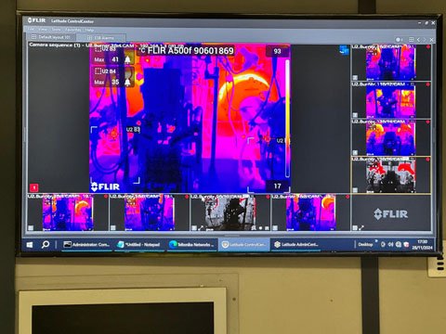

*Thermal imaging cameras monitor components such as transformers, cabling, and valve actuators, which detect changes in heat signatures that may signal wear, stress, or failure risk.*

In light of the Iberian Peninsula outages, where a single transmission fault reportedly triggered widespread failures, this kind of proactive defence isn’t just prudent, it’s essential.

In fact, the solution has already helped demonstrate the capability to initiate plant shutdowns within 15 seconds of fire detection- a key requirement for preventing cascade failures that could disrupt almost half of Ireland’s grid, for which it offers a critical redundancy to bolster the system’s capacity when it is overworked, overloaded or simply undergoing necessary maintenance.

**Granular data and definitive deltas:** Condition Monitoring without the guesswork

Beyond fire detection, the system provides always-on insight into asset health. Cameras monitor components such as transformers, cabling, and valve actuators, which detect changes in heat signatures that may signal wear, stress, or failure risk. With over 16,000 reference points per image, these thermal feeds offer far more granular data than traditional sensors or manual inspections.

Engineers on-site no longer need to rely on scheduled walkarounds or visual estimates. Instead, they receive real-time alerts, thermal imagery, and exact location data; enabling fast, informed decisions without needing to interpret temperature deltas by eye. In fact, the site has now ordered more cameras to build into the success of this new system and with the learning that has come from the project, it has pushed Butler Technologies to develop a new application for ESB Energy shift managers to receive push notifications via SMS, email and though the app - for seamless cross-platform monitoring.

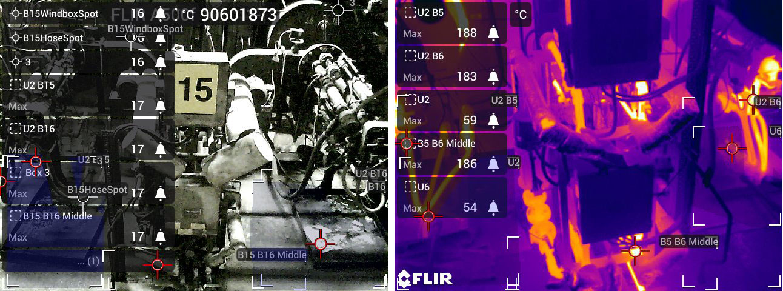

*While the visual image appears to be without findings, the thermal image shows five alarms where preset temperatures have been exceeded.*

**As *John Free, Senior Account Manager at Butler Technologies*** described it, the shift is not about usurping skilled laborers, but instead focused on enhancing it: “This isn’t about replacing engineers. It’s about empowering them. With fewer hands on deck, this system becomes an extra set of eyes they can trust.”

An integrated and intuitive industry first

One of the strongest advantages of the system lies in its end-to-end design. Thermal imaging, back-end software, and user interface were all deployed as a unified solution, enabling a seamless integration into the site’s existing video management system.

Alarms are instantly visible through the centralized platform. If triggered, thermal zones automatically expand onscreen, directing operators precisely where to look and act. Critically, thanks to the fully native architecture, there’s no third-party hardware to maintain or troubleshoot.

The system features the [FLIR A500f and A70 thermal imaging cameras[5],](https://www.flir.co.uk/products/a500f_a700f-environmental-housing-camera/?vertical=rd+science&segment=solutions) with plans to scale to newer devices like the FLIR A700f and FLIR A700f PT as the station prepares to onboard next-generation infrastructure, including cloud-based monitoring and AI-driven anomaly detection.

Built for today, primed for tomorrow’s ever-more ambitious applications

While the station continues to operate as an oil-fired facility for now, it also serves as the national test site for upcoming renewable energy initiatives, which include offshore wind. That future-facing mission required a monitoring solution that could evolve alongside it and better fit with Ireland’s largely green energy grid.

The system is already supporting exploratory work on advanced AI applications, which include using visual monitoring to confirm valve positions or track operational trends across thermal patterns. These insights could help pave the way for predictive maintenance, remote inspections, and safer operations at scale.

**An ESB Project Engineer said:** "We chose FLIR technology because it provides the real-time precision and scalability needed to safeguard critical infrastructure. In an industry where uptime is everything, FLIR’s thermal imaging offers the level of early detection and monitoring we require to protect both our assets and the national grid."

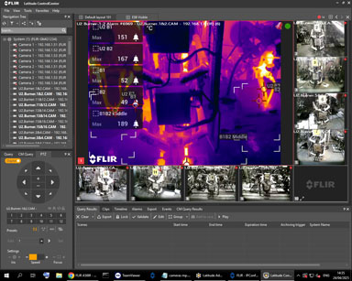

*The FLIR software shows temperature alarms for burner 1 and 2 in the thermal image.*

Immediate gains for Ireland’s grid

As national grids face increasing pressure to modernize, projects like this demonstrate how thermal automation can deliver immediate gains in safety and reliability, all while laying the groundwork for smarter, greener energy systems.

This station is the first in Ireland to implement such a comprehensive monitoring solution and one of the first in Europe to tie it directly into future renewable operations. It’s a powerful showcase for how thermal vision, when done right, can go far beyond temperature; it protects assets, accelerates response times, and helps keep the lights on for everyone.

ESB Energy has plans to further hone the use of Early Fire Detection systems, like those which FLIR specialises in creating. The system in place at Moneypoint Power Station has become a huge talking point within the organization, which has led Butler Technologies to a new lead monitoring substations with similar builds. This application is to monitor connection points in the substation and identify failures; a critical trial for ESB to see the use cases of the system within substations and, if successful, has the potential to be rolled out to over 500 substations in Ireland.

_______

***Meta description for EPI:*** *A first-of-its-kind thermal monitoring system at a key Irish power station is delivering real-time fire detection, continuous condition monitoring, and AI-ready infrastructure - marking a major leap in grid resilience and future-proof energy operations.*

1. https://edition.cnn.com/2025/04/28/europe/spain-portugal-power-outages-intl
2. https://www.esbenergy.co.uk
3. https://www.butlertech.ie
4. https://www.carbonbrief.org/qa-what-we-do-and-do-not-know-about-the-blackout-in-spain-and-portugal
5. https://www.flir.co.uk/products/a500f_a700f-environmental-housing-camera/?vertical=rd+science&segment=solutions